**Setting** **Up** **Application** **Environment**

**Create an** **Account in** **Sendgrid**

|  |  |
| --- | --- |
| Date | 10 November 2022 |
| Batch ID | PNT2022TMID39620 |
| Project Name | Skill and Job Recommender Application |
| Team Members | REVANTH PRIYAN M, SRIHARI K, RAMESH KV RUBAN KUMAR K |

**Step** **1:**

Go to official Sendgrid website:[***https://sendgrid.com/*,**t](https://sendgrid.com/)hen click start forfree.



**Step 2:**

Then go to Registration Page, you need to give all the details required for creating a Sendgrid account and finally click create button. The below screenshot will show the registration Process.

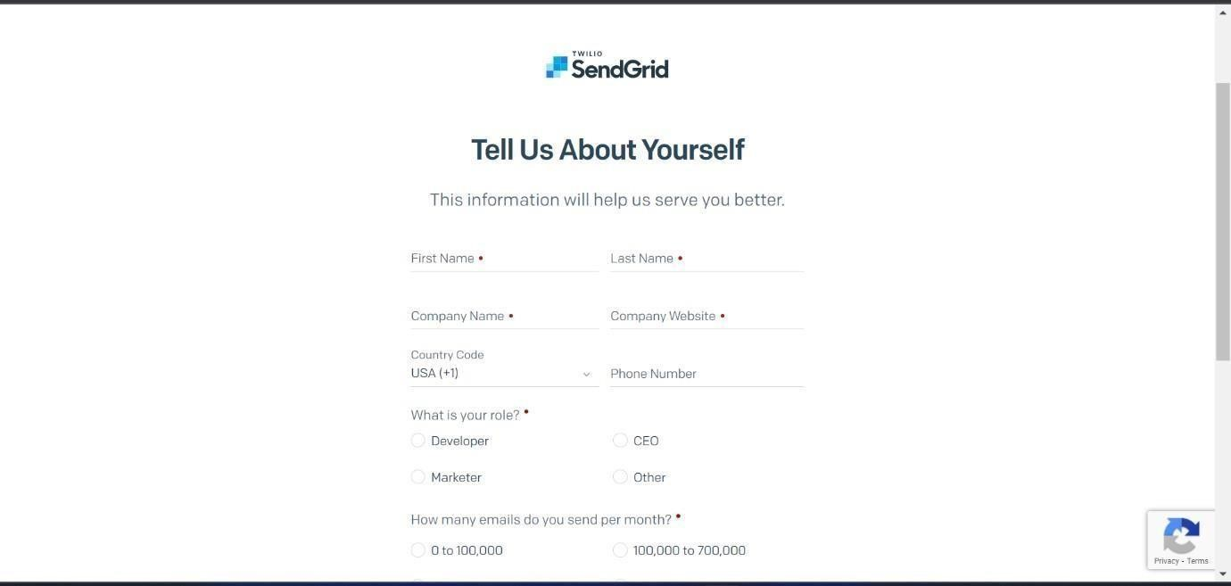

**Step** **3:**

Then it will redirect you to a home page of your sendgrid account.

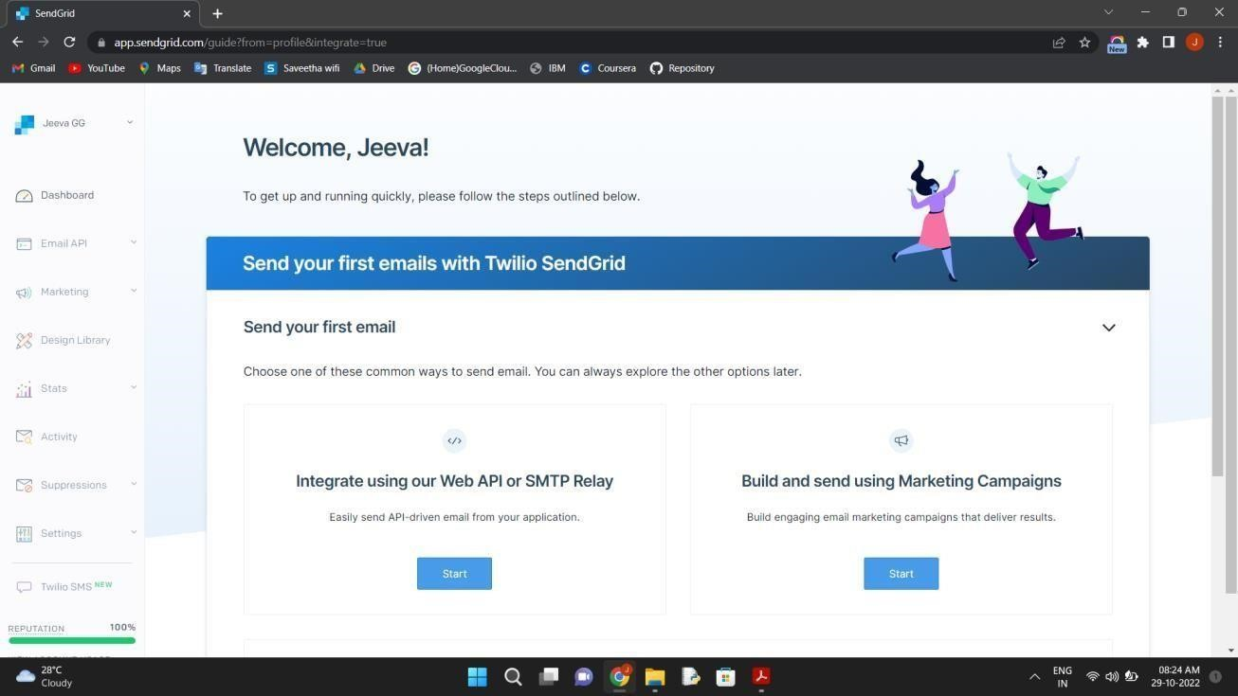

**Vishnu!**

vishnu

**Step** **4:**

Finally ,you have created your account and now you can access the sendgridaccount.